

Damp & Mould
Policy V2

October 2025

Lead officer | Mark Jones
Author | Andy Turner
Version number | 2
Date agreed | 23 October 2025
Agreed by | Operations Committee
Review date | 3 years from approval date
Diversity compliant | Yes
Equality Impact Assessment required | No
Data Protection compliant | Yes
Health and Safety compliant | Yes

Contents

Item |  | Page
1. | What this policy is about and why we need it | 3
2. | Who does this policy apply to | 3
3. | Our policy is  - Objectives  - Scope  - Responsibilities | 3  4  7
4. | How we will monitor this policy | 7
5. | Equality & Diversity | 8
6. | Data Protection | 8
7. | Procedures and other documents that link to this policy | 9
8. | Links to other policies, legislation, and regulations | 9
9. | Legislation | 9
10. | When this policy will be reviewed | 9
11. | Jargon Buster | 9

- What this policy is about and why we need it

  - This policy identifies Acis’ approach to the monitoring and management of damp and mould issues.

  - We need this policy to ensure that we:
- Do everything we reasonably can to make sure our customers stay safe, healthy, and well in their homes. Damp and mould are issues which can have a serious impact on the health and well-being of our customers, and cause damage to homes.
- To demonstrate the importance and organisational priority that Acis places on the ability of our customers to live in safe homes, to our customers, staff, and stakeholders

2. Who does this policy apply to?

  - This policy applies to all customers who raise issues with Acis about the presence of damp and mould spores in their properties. Different property archetypes will need to be looked after differently by Acis and by customers. For leaseholders, we will meet the responsibilities as set out in terms of the lease.
  - The policy also applies to employees, stakeholders, and contractors who have identified responsibilities both within this document and in line with supplementary procedures/ information and guidance.

3. Our policy

3.1 Objectives

The objectives of this policy are to:

- Provide dry, warm, healthy, and safe homes for our customers which are free from damp and mould.
- Comply with legislative, regulatory, and contractual (including tenancy, lease, and shared ownership) obligations
- Ensure the fabric of our homes is protected from deterioration and damage resulting from damp and mould and related issues by following the preventative and remedial actions outlined in this Policy.
- Develop a proactive and positive culture regarding the treatment of issues raised by customers reporting presence of damp and mould spores.
- Adopt a hierarchical, risk-based approach when diagnosing and resolving damp and mould issues, with a clear priority given to those customers with underlying health issues and vulnerabilities.
- Support customers in resolving damp and mould issues where they result from or are exacerbated by the use of the property, and provide our customers with appropriate, clear, sensitive, practical, and accessible advice.
- Ensure colleagues are trained to enable them to spot potential causes of damp, mould, and condensation so they can advise or signpost customers, diagnose problems, and provide solutions.
- When applying this policy, make reasonable adjustments for people who have a disability and consider the provisions of the Equality Act 2010.

3.2 Scope

Causes
- Mould is a type of fungus. It spreads through spores, which are invisible to the naked eye but are in the air around us all the time and can quickly grow on surfaces where damp persists, or water has formed into a visible covering.
- Damp is an excess of moisture that can’t escape from a structure, which can also go on to cause significant damage to the building such as collapsed ceilings and rotten timber elements such as windows and doors.
- There are four main causes of damp in homes in England, each of which may require different solutions:
  - Water leaks from defective supply and waste pipework affect both external and internal walls and ceilings. The affected area looks and feels damp to the touch and stays damp regardless of the prevailing weather conditions. It is the result of a problem or fault with the home, which requires repair.
  - Rising damp is caused by water rising from the ground into the home. Water gets through or around a defective damp proof course (DPC) or passes through the masonry that was built without a DPC. Rising damp will only affect basements and ground floor rooms and will be present all year round. It is extremely uncommon but is generally the result of a problem or fault with the home, which requires repair. This will usually be AGL’s responsibility.
  - Penetrating damp appears because of a defect in the structure of the home which allow water to pass from the outside to the floors, walls or ceilings. Penetrating damp is far more noticeable following a period of rainfall and will normally appear as a well-defined damp-patch which looks and feels damp to the touch. It is the result of a problem or fault with the home, which requires a repair. Responsibility for the repair will depend on the type and location of the fault.
  - Condensation is the most common type of damp and is caused by water vapour in the air inside the property meeting a colder surface, such as a window or wall. The drop in temperature causes liquid water to form on the surface and then soak in. It is usually found in areas in the property that tend to have a lot of moisture in the air, or to be cold generally. It is also found in areas of low air circulation such as behind wardrobes and beds, especially when they are pushed up against external walls. All our properties can be affected by condensation because the climate is often cool and wet. Normal household activities also constantly release moisture into the air. Good practice in the home minimises and alleviates condensation, and in many cases will prevent it causing damp and persistent mould. However, the root cause can be a problem that requires an AGL repair or an improvement to the home. In other cases, a different solution may be needed, for example, in cases of overcrowding.

Further detail

Preventative action
- We will utilise the Stock Condition Survey programme alongside other internal property and customer interventions including the heating servicing programme, EPC and Asbestos surveys to identify any category 1 hazards or high scoring category 2 hazards, as specified in the Housing Health and Safety Rating System (HHSRS). These will be actioned immediately on identification.
- We will adopt a hierarchical risk-based approach to identify homes that have or may be at risk of developing problems with damp and mould, following a standardised risk matrix. We will analyse problematic and potential risk property archetypes and use stock condition,repairs and customer data to help us understand the current risk profile in relation to damp and mould and to identify any pre-emptive actions.
- We will seek to mitigate any increased risks of damp and mould arising as a result our work to decarbonise our homes by developing effective and efficient property specifications.
- When a property becomes vacant, and prior to re-letting, we will seek to identify and remedy any issues which may cause damp utilising the Acis Lettable Standard or Acis Student specification to manage all work.
- Where the gas supply at any property has been capped, we will undertake at least an annual internal inspection to address the potential damp and mould implications on the structure of the property.
- We will ensure all teams undertaking any non-property related visits look out for signs of damp and mould whenever they visit a customer’s home or student flat and escalate any findings immediately via the appropriate route to ensure Acis meets its case audit and reporting obligations
- Acis has identified 254 properties classed as Hard to Heat/Hard to Treat. Due to the single skin construction of this property archetype, there is an increased risk of damp and mould issues and these properties will also be subject to an annual internal inspection.
- We will contact potentially vulnerable customers pro-actively to manage damp, mould and condensation risks. Where a damp and mould issue is raised as part of a wider concern we will utilise our safeguarding procedures to support the customer as required. A portfolio of information will continue to be provided via our newsletters and on our website to raise awareness about the causes of damp and mould.

Dealing with damp and mould
- Acis will utilise a structured, staged, embedded approach to advising customers who report any damp or mould in their homes to conform with the requirements of the ‘Hazards in Social Housing (Prescribed Requirements) (England) Regulations 2025’ also known as Awaab’s Law.
- To meet the requirements of Awaab’s Law, Acis will:

  - investigate any potential emergency hazards and, if the investigation confirms emergency hazards, undertake relevant safety work as soon as reasonably practicable, both within 24 hours of becoming aware of them
  - investigate any potential significant hazards within 10 working days of becoming aware of them
  - produce a written summary of investigation findings and provide this to the named customer within 3 working days of the conclusion of the investigation
  - undertake relevant safety work within 5 working days of the investigation concluding, if the investigation identifies a significant hazard
  - begin, or take steps to begin, any further required works within 5 working days of the investigation concluding, if the investigation identifies a significant or emergency hazard. If steps cannot be taken to begin work in 5 working days this must be done as soon as possible, and work must be physically started within 12 weeks
  - satisfactorily complete works within a reasonable time period
  - secure the provision of suitable alternative accommodation for the household, at the social landlord’s expense, if relevant safety work cannot be completed within specified timeframes
  - keep the named customer updated throughout the process and provide information on how to keep safe
- Advice will be given at the first point of contact, through the Customer Service Centre or Acis Student reporting process, who have access to an internally produced guidance document and risk matrix to identify the cause of any damp or mould issues and an effective solution, proportionate to the reported issue. Advisors will request photographs of any damp or mould, posted by customers at the time of reporting, through the My Acis portal to help identify the appropriate solution. If the reported condensation or damp issue, cannot be resolved through advice or by the customer directly, or requires further investigation, an engineer or Supervisor will visit the customer to carry out a diagnosis and if required, complete any minor repairs e.g., mould treatment with fungicidal wash, improved ventilation, repairing any cracks or failed sealant etc.
- If the engineer or Supervisor are unable to resolve the issue or previous repairs/treatments were unsuccessful, a referral will be made to a dedicated Surveyor in the Asset Team who will oversee the damp or condensation issue until resolved. This may include installation of data tags to measure temperature and humidity over a 28-day period to inform effective diagnosis of any mould or condensation related issues.
- Where internal remediation measures do not resolve the issue, the Asset Team will instruct a specialist damp organisation to survey the property, taking relative humidity and moisture content readings and typically recommending a basket of repairs to remedy leaking pipework, and rainwater goods, and/or replace faulty humidistat extractor fans, install positive ventilation units and deal with hydroscopic salts in plaster.
- We will triage all damp and mould cases to establish where customers have any relevant underlying health issues or vulnerabilities so that these cases can be prioritised.
- For more complex cases where the customer or a member of their household has underlying health issues and where more intrusive building work is required, we will work with operational teams to explore short or longer term decant options.
- We will keep customers informed and updated about any property inspections, diagnosis of issues and the timetabling of works, where these are required.
- If we are unable to gain access and the integrity of the property, its fabric and/or the safety of the customer or those in the vicinity of the property is compromised, we will take appropriate enforcement action.
- We will consider appropriate compensation where our failure to deliver the service we have committed to requires this.

Supporting our customers
- We will give customers advice and support on how to prevent damp and what they should do to remove mould.
- Where we aware of fuel poverty issues impacting on damp and mould cases, we will work with customers to ensure that they are receiving the support and income to which they are entitled.

Staff training
- We will ensure that the Customer Service Centre and other relevant teams including engineers, ASM’s Estate Officers and student operational teams receive regular training on the diagnosis of condensation and mould from the Asset Team alongside recognised or accredited expert external training.

Responding to complaints and learning lessons
- We aim to resolve complaints as quickly as possible without customers needing to resort to disrepair claims and legal action.
- We will review all feedback and ensure we learn lessons from damp and mould cases, update our technical approach and how we communicate with customers, to improve future responses.
3.6 Responsibilities

The table below identifies key responsibilities

Position | Role/ Responsibility
Chief Executive | - Policy owner
Director of Property Services | - Implement this policy  - Make available adequate resources to enable delivery of this policy
Head of Property Development & Assets | - Achieve overall objectives and targets
Asset Investment  Manager | - Implement, monitor, manage and report on operational performance  - Report performance to the appropriate committee
Head of Customer Operations , Head of Repairs Delivery and Operations Manager – Acis Students | - Assist in achieving overall objectives and targets
Asset Surveyors/Quantity Surveyor/Site Services Manager | - Ensure all operational targets are met  - Ensure required inspections are completed  - Undertake and complete any corrective actions within the defined timescales
Repairs & Maintenance, NBDs, Customer Service Centre and Acis Student teams | - Support the implementation and delivery of this policy by assisting those involved
Finance | - Managing a programme of internal and external audits which will check that the policy and procedure is being followed
Joint Leadership Team | - Where appropriate, ensure members of their directorate undertake any identified roles and responsibilities  - Support the implementation and delivery of this policy
Contractors | - Ensure all contractual targets are met  - Ensure required inspections are completed and recorded  - Undertake and complete any corrective actions within the defined timescales  - Assist in signposting customers to relevant Acis referral options  - Undertake appropriate Acis/external training for all customer-facing staff

- How we will monitor this policy

  - This policy will be reviewed and externally reviewed every 3 years for accuracy and appropriateness or sooner where any legislative changes or requirements dictate.
  - Operational performance will be monitored monthly by the Asset Investment Manager and will be reported to the Board via the Operational Scorecard and to the Operations Committee utilising the following KPI’s:
    - Number of emergency cases raised (response within 24 hours)
    - Percentage of emergency cases responded to within target
    - Number of applicable but non-emergency cases raised (response within 10 days) .
    - Percentage of non-emergency cases responded to within target
    - Number of non-Awaab’s Law applicable cases raised (response within 28 days)
    - Percentage of non-applicable cases responded to within target
  - In addition, where customers have used the services covered by this policy and wish to provide feedback, including suggested improvements, these will be collated and used at the time of the review.

- Equality & Diversity

  - AGL is committed as an employer and provider of housing services to equality of opportunity for all. In addition to this statutory duty under the Equality Act 2010, it is further committed to developing a culture, which recognises wider social diversity in its communities and therefore respects and recognises the values and needs of individuals regardless of whether they belong to a particular section of society or group provided for by legislation.
  - The group will work with minority and vulnerable groups, support groups, customer forums, and external agencies to ensure they contribute to policy and service development.
  - All customers will have access to this document upon request.
  - This document can be translated or provided in alternative formats (e.g. large print, Braille, audio) upon request.
  - Equality and Diversity awareness training is mandatory for all staff.
  - Contractors delivering the service will be expected to follow AGL’ Equality and Diversity Policy.

- Data Protection

  - All parties referred to in this policy must abide by the 6 principles of the General Data Protection Regulations as detailed below:
- Lawfulness, fairness and transparency
- Purpose limitations
- Data minimisation
- Accuracy
- Storage limitations
- Integrity and confidentiality

- Procedures and other documents that link into this policy

  - The following procedures link to this policy
- Damp, Mould & Condensation Process Map, Risk Matrix and Triage Questions (See Appendices 1-3)
- Repairs Policy
- Safeguarding Policy
- Hoarding Policy
- Capital Works process map
- Capital works procedure

- Links to other policies, legislation and/or regulations

  - Other policies that link into this policy are:
- Asset Management Strategy
- Repairs Policy
- Health & Safety Policy
- Equality & Diversity Policy
- Lettable Standard
- Void Policy
- Decant Policy

- Legislation

  - In developing this policy, information, guidance, and references have been taken from the following:
- Housing Act 2004
- Health & Safety at Work Act 1974 (HSWA)
- The Regulator’s Consumers Standards (e.g. Home Standard)
- Hazards in Social Housing (Prescribed Requirements) (England) Regulations 2025, also known as Awaab’s Law
- Defective Premises Act 1972
- Environmental Protection Act 1990
- Landlord and Tenant Act 1985 (Section 11)
- Decent Homes Standard 2006
- Equality Act 2010
- Homes (Fitness for Human Habitation) Act 2018
- Pre-Action Protocol for Housing Conditions Claims (England), 2021

- When this policy will be reviewed

  - This policy will be reviewed every 3 years or in the event of a change in regulations.

- Jargon buster

Reference | Definition
Decent Homes | The Decent Homes Standard is a technical standard for public housing introduced by the United Kingdom government.  The criteria for the standard are as follows:  - it must meet the current statutory minimum standard for housing  - it must be in a reasonable state of repair  - it must have reasonably modern facilities and services  - it must provide a reasonable degree of thermal comfort.  The standard was updated in 2006 to take account of the Housing Act 2004, including the implementation of the Housing Health and Safety Rating System (HHSRS).

Appendix 1 – Damp & Mould Process Map

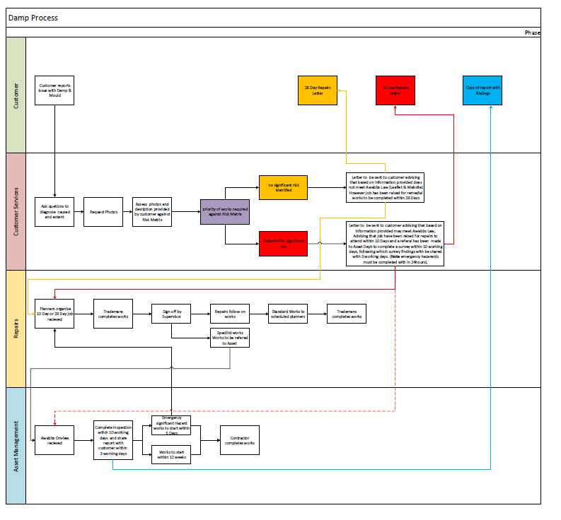

Appendix 2 – Damp & Mould Risk Matrix

At Risk Category
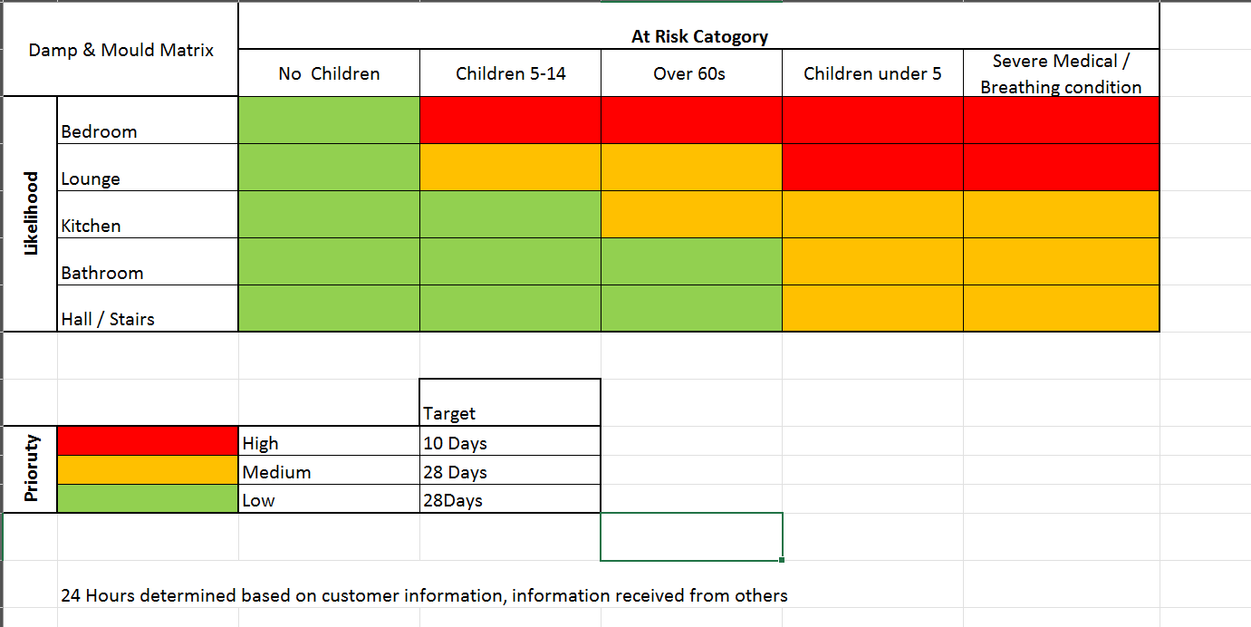

Severity Assessment

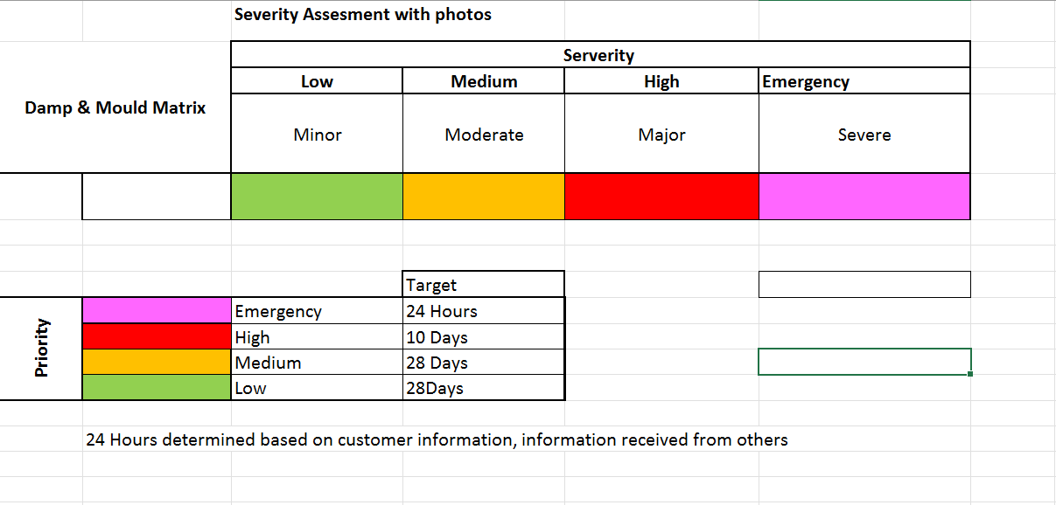

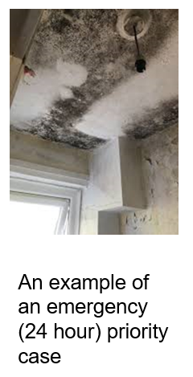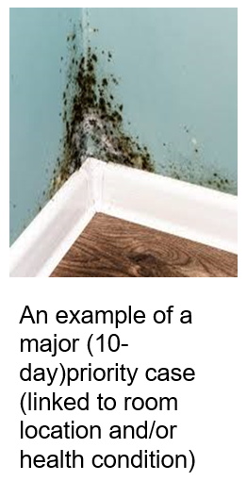
Appendix 3 – Triage Form

Damp and Mould Initial Report 
Address:
Reported by:
Date:
Acis Representative:

General Description:

Whereabouts is the Damp and Mould? (Please tick boxes which apply)
Bedroom ☐ - Number of bedrooms affected?
Childs Bedroom ☐
Kitchen ☐
Bathroom ☐
Living Room ☐
Hallway ☐
Other ☐

Where is the mould? (Please tick boxes which apply)
Walls ☐
Ceiling ☐
Windows ☐
Other ☐ Details:

What does it look like? (Please tick boxes which apply)
Black Mould ☐
Wet Stain clear ☐
Brown water stain ☐
Salty (Brown/white) ☐

How Big is the area affected?

Are there any water or waste pipes close by? (May be leaking)

Are your extractor fans working? (Please tick box which applies)
Kitchen - Yes ☐ No ☐ don’t have one ☐
Bathroom - Yes ☐ No ☐ don’t have one ☐

How long has the Damp and Mould been present?

Have you reported this previously? (Check repair history)
Reported within last 3 months ☐
Reported within the last 6 months ☐
Reported with the last 12 months ☐
Reported within 12 to 24 months ☐
Reported over 2 years ☐
Never reported before ☐

Are you able to send any photos as this will allow us to prioritise you correctly?
WhatsApp?
Email?

Household Details
How many people live at the property?

Are any children at the property? (What are their ages)

Does anyone have in the household that meets these criteria? (Please tick boxes which apply)
- pre-existing health condition (for example allergies, asthma, COPD, cystic fibrosis, other lung diseases and cardiovascular disease) ☐
- who have a weakened immune system, such as people who have cancer or are undergoing chemotherapy, people who have had a transplant, or other people who are taking medications that suppress their immune system ☐
- pregnant women, women who have recently given birth. ☐

Risk Matrix Assessment

At Risk Category
High ☐ Medium ☐ Low ☐

Severity
High ☐ Medium ☐ Low ☐ Severe ☐

Frequency
High ☐ Medium ☐ Low ☐

24 Hours Jobs are triggered as a result of a severe risk.
Any categories selected high will trigger the need for significant risk 10-day job to be raised.

Job raised
24 Hours ☐ 10 Day ☐ 28 Day ☐

